TrailBot Design Proposal

Group 14

Brandon Christler, Michael Hitchcock, Garrett Monast, Yifan Wu

ECE 4900

10/9/2018

**Table of Contents**

Page

Executive Summary 2

Introduction 3

Requirements Specification 3

Constraints 4

Considered Designs (Table 1) 4

Design Proposal (Figures 1, 2) 5,6

Testing and Validation 6

Components 6

Task List and Milestones (Table 2) 7

Gantt Chart (Table 3) 8

Immediate Plans 8

Required Hardware and Equipment 9

Budget Estimate 9

Risks 9

Conclusion and Recommendations 10

References and Resources 11

**Executive Summary**

Joggers and walkers face many inconveniences while on the go, and even more so during hours of limited visibility. A solution is needed that provides a jogging or walking person a safe compartment for their possessions, a light for their path should they need it, and a way to charge their mobile devices and ensure safety, all while maintaining a close proximity to the user, and avoiding obstacles in its path. The solution must be affordable and function, must keep a close distance to the user while they are moving, circumvent any obstacles in its path, and possess an appropriate battery life. The solution, which utilizes the power of Arduino, the ruggedness of a selected chassis, and the reliability of a 14.8V, 5200 mAh Lithium-Polymer battery, is TrailBot. This design has an estimated cost of $150, a battery life of at least one hour, and utilizes IR and ultrasonic sensors to track the user and avoid obstructions.

There are few significant constraints that will limit TrailBot, which include weight, cost, and safety. TrailBot will use a solid housing to mitigate shock risks, reliable sensors to prevent collisions, and quality batteries to eliminate environmental hazards. Though a drone was considered as a solution, it was decided that TrailBot, a ground-based robot, has advantages in complexity, battery life, weight limit, cost, and functional capacity. The team plans on integrating each subsystem, shown in Figure 2, sequentially, and performing rigorous tests for components, individually and cooperatively, in order to ensure proper function. A timeline, along with completion percentages, is available in the Gantt chart (Figure 3) on pages 8 and 9. The first major milestone of the project will be the completion of a mobile robot, without a protective shell, but with all sensors and sensing capabilities integrated. The second milestone will be the installation of a protective shell for the robot, and the re-verification of proper function. The final milestone will be an application test, set in the appropriate environment, that involves all capabilities, peripherals, and expectations of the robot, including a function test under load.

The group has accomplished approximately 53% of all design, construction, programming, testing, and management tasks related to this project. Immediate plans include the finalization of IR sensor research and code, and the implementation of the IR sensors, along with the ultrasonic sensor, onto the design; testing and adjustments following this integration, if necessary. After this, the group will finalize any peripherals that will be included in the final design, and begin to work on an exterior shell for the design that will accommodate all of the design components. There are some inherent risks working with an electronic device meant for outdoor use, particularly one meant to be entirely hands-free. These risks include the possibility of shock to the user, and damage to components as a result of moisture or debris. They also include the risk of collision and injury to the user as a result of its autonomy. These risks will be mitigated with proper engineering designs and procedures, as well as thorough testing to ensure proper function.

**Introduction**

The purpose of this report is to introduce a problem statement, analyze requirement specifications, and propose a design solution for the problem. This report will provide an analysis of constraints, safety issues and relevant standards, design concepts considered, and a proposed design. Plans for testing and verification will be included for the design solution, along with required components and subsystems.

Many people enjoy walking or jogging on trails and roads, but due to busy schedules and time constraints, they are often restricted to doing so at night, or during hours of limited visibility. In addition, joggers usually carry various encumbering items, such as keys, phones, and water bottles. In order to improve an individual’s safety, and eliminate the inconvenience of carrying several items, a solution is desired. This solution should follow the user while they are moving, provide them light, and provide them a carrier for their possessions. Additional functions may be desired, and may be integrated. The solution should be specific to joggers, nighttime or otherwise, and should keep their interests and convenience in mind.

**Requirements Specifications**

There are several requirements regarding the design solution, either marketing considerations or engineering considerations. Marketing requirements, which are those that are considered desirable to consumers, make a product more publicly appealing. Marketing requirements for a design solution for the problem statement above include:

* Affordable – minimize price.
* Battery life – robot should be able to operate for a minimum of one hour.
* Speed – robot must be able to keep pace with a person jogging (~8 mph).
* Functionality – robot must provide multiple functions to the user, and be easy to operate.
* Accurate – robot should be able to maintain a close following distance.
* Safety – robot will maintain safe distance from user, and will avoid obstacles so as to not to collide with objects or people. Robot will be covered with a shell to protect it from the elements.

Engineering requirements are technical requirements that would need to be provided by the designs components, and describe the technical characteristics of the design. These include:

* Battery should be large enough to power a brushless motor under appropriate load, and discharge at C rate.
* System will utilize IR and ultrasonic sensors to track user while avoiding obstacles.
* System cost should not exceed $150.
* System will maintain a following distance of approximately five feet.

**Constraints**

The main constraints of the design to be considered are the weight and safety of the design. The device will not have any political or environmental constraints, other than to not have any parts cause any environmental harm (e.g. battery acid leakage), and its sole economical constraint is its cost limit. Being that the device is electronic, and it will be used outdoors, the safety of users against electric shock is an important consideration. The design will include a weather-resistant cover to protect it from the elements, and in turn the user from shock. In addition, the final product will maintain a safe distance from the user, so as not to collide with or obstruct the user. The weight constraints of the design will not a major consideration if a stable chassis is selected; however, greater loads will decrease performance and efficiency, so it will be accounted for.

**Considered Designs**

There were two major designs considered as solutions for the problem statement. The first design was a drone, or an airborne robot, which followed the user, avoided obstacles, and provided light and other functions to the user. Issues with this particular design, specifically strict weight consideration, technical complexity, and limited time and space, resulted in the dismissal of this design proposal. The second design proposal took the same general functionalities, and incorporated them into a ground-based robot. The robot will still follow the user and detect obstacles, but complexity would be reduced. Size and weight become much less significant factors in this design process, because of the stability and robustness of a solid chassis. As a result, additional components and functions may be added to the design, including larger, longer-lasting batteries. Finally, the cost of a ground-based robot will be less expensive than that of a drone. Table 1 describes the advantages of each design concept, showing that the ground-based robot is clearly the better option for this application.

|  |  |  |
| --- | --- | --- |
|  | Drone | Ground Bot |
| Complexity |  | **X** |
| Weight Limit |  | **X** |
| Possible functions |  | **X** |
| Maneuverability | **X** |  |
| Battery Life |  | **X** |
| Cost |  | **X** |
| Market Interest | **X** |  |

Table 1: Designs and their advantages (X’s represent advantages).

**Design Proposal**

The team’s design concept is a 4-wheeled, ground-travelling robot capable of both major and peripheral functions. The robot will follow the user, maintaining a five-foot distance while the user is jogging, and a shorter distance (less than or about 2 feet) when the user is stopped. Infrared sensors will be used to determine the direction of the target, and an ultrasonic sensor will be used for collision avoidance. The robot will have a weather-resistant body which will house a docking/charging station for a phone, a small compartment for small objects, and additional carriers for water bottles. The robot’s movement and sensors will be controlled by an Arduino Uno, and will be tracking an IR transmitter beacon worn by the user. There will be an accessory shaft on the body, on which an LED rack can be mounted. Finally, a charging panel will be available on the side of the body, so that the user can charge the robot. A preliminary concept and layout of the design is given by Figure 1, and a high-level block diagram is given by Figure 2.

The team will control this robot using an Arduino Uno, which was selected for its versatility, low cost, and easy setup and interface. The body will be driven with a brushless motor, which was already present on the chassis selected by the team. The motor will be able to drive the chassis, at a total weight of approximately 10-15 lbs, at a speed of at least 8 mph--the average jogging speed. The dimensions of the design will be approximately 2’x1’x2’, with a shaft mounted to the body for accessories that will stand approximately 12”-18” above the body.

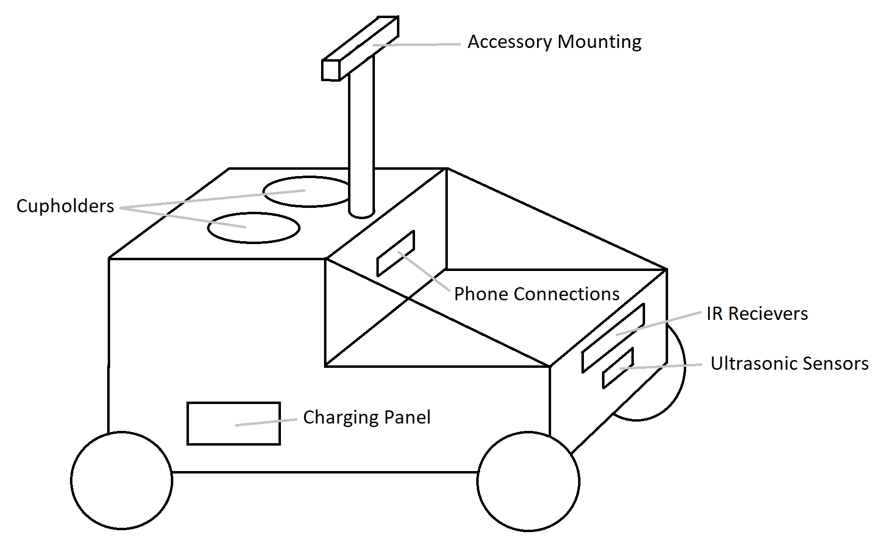

Figure 1: Proposed Design Concept

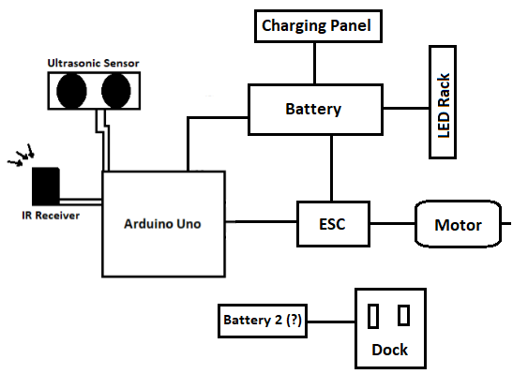

Figure 2: Component-Level Block Diagram

**Testing and Validation**

The team will focus on individual systems and components sequentially, starting with basic functions such as moving and steering, to the more complex functions such as obstacle avoidance and user-tracking. Simple tests will be conducted to understand or verify the proper function of individual components, and will occur during the beginning stages of design. Complex tests will be conducted towards the end of the construction stages, when all of the individual subsystems become integrated together, and will include various functions and events happening simultaneously. Final tests will include all components, and will take place in appropriate, applicable settings.

**Components**

The components used for the TrailBot include:

* Arduino Uno Microcontroller
* Electronic Speed Controller
* Brushless Motor
* Servo Motor (used for steering)
* Ultrasonic Sensor (obstacle avoidance)
* IR Sensor Array (provides directional sensing)
* IR Transmitter Beacon
* Charging Dock
* 14.8V, 5200 mAh LiPo Battery
* Item carrier

**Task list and Milestones**

|  |  |  |
| --- | --- | --- |
| # | Description | Milestone |
| 1 | Determine exact functions |  |
| 2 | Gather parts |  |
| 3 | Assemble mobile portion |  |
| 4 | Program robot |  |
| 5 | Verify robot function (particularly with sensors) | **X** |
| 6 | Mount/wire docking station |  |
| 7 | Mount/integrate LEDs |  |
| 8 | Install carrier and peripherals | **X** |
| 9 | Build and install exterior/shell |  |
| 10 | Verify correct functions | **X** |

Table 2: Tasks and Milestones

Table 2 shows the general tasks that must be accomplished by the team, and designates milestones among them, which mark significant accomplishments. The first milestone will be after the mobile portion of the robot is complete (before anything else is mounted to the robot), programmed, and verified to work appropriately with its sensors (e.g. user tracking, obstacle avoidance). The second milestone will be the completion of the build of the entire robot, all mounted hardware included, robot body excluded. The final milestone will be the verification that, once all hardware is mounted, and the robot is encased in a protective shell (shielding it from rain, mud, etc.), the robot functions without issues as expected.

**Gantt Chart**

|  |  |  |  |  |  |  |  |  |  |  |  |  |  |  |  |  |  |
| --- | --- | --- | --- | --- | --- | --- | --- | --- | --- | --- | --- | --- | --- | --- | --- | --- | --- |
|  | W1 | W2 | W3 | W4 | W5 | W6 | W7 | W8 | W9 | W10 | W11 | W12 | W13 | W14 | W15 | W16 | Progress |
|  | 21-Aug | 27-Aug | 3-Sep | 10-Sep | 17-Sep | 24-Sep | 1-Oct | 8-Oct | 15-Oct | 22-Oct | 29-Oct | 5-Nov | 12-Nov | 19-Nov | 26-Nov | 3-Dec | **Total: 53%** |
| Design |  |  |  |  |  |  |  |  |  |  |  |  |  |  |  |  | **80%** |
| Chassis |  |  |  |  |  |  |  |  |  |  |  |  |  |  |  |  | 90% |
| Controller |  |  |  |  |  |  |  |  |  |  |  |  |  |  |  |  | 90% |
| Software |  |  |  |  |  |  |  |  |  |  |  |  |  |  |  |  | 80% |
| Sensors |  |  |  |  |  |  |  |  |  |  |  |  |  |  |  |  | 60% |
| Additional Functions |  |  |  |  |  |  |  |  |  |  |  |  |  |  |  |  | TBD |
| Build |  |  |  |  |  |  |  |  |  |  |  |  |  |  |  |  | **73%** |
| Chassis |  |  |  |  |  |  |  |  |  |  |  |  |  |  |  |  | 70% |
| Controller |  |  |  |  |  |  |  |  |  |  |  |  |  |  |  |  | 80% |
| Sensors |  |  |  |  |  |  |  |  |  |  |  |  |  |  |  |  | 70% |
| Test |  |  |  |  |  |  |  |  |  |  |  |  |  |  |  |  | **57%** |
| Movement |  |  |  |  |  |  |  |  |  |  |  |  |  |  |  |  | 90% |
| Following |  |  |  |  |  |  |  |  |  |  |  |  |  |  |  |  | 0% |
| Obstacle detection |  |  |  |  |  |  |  |  |  |  |  |  |  |  |  |  | 80% |
| Additional Functions |  |  |  |  |  |  |  |  |  |  |  |  |  |  |  |  | TBD |
| Present |  |  |  |  |  |  |  |  |  |  |  |  |  |  |  |  | **0%** |
| Recordsn |  |  |  |  |  |  |  |  |  |  |  |  |  |  |  |  | 0% |
| Presentation |  |  |  |  |  |  |  |  |  |  |  |  |  |  |  |  | 0% |
| **Milestones** |  |  |  |  |  |  |  |  |  |  |  | **X** |  | **X** | **X** |  |  |

Table 3: Gantt Chart

**Immediate Plans**

While much of the design and build have been completed, there are still some tasks that must be done in the immediate future. Some of the immediate tasks will be completed simultaneously. These “next steps” include:

* Integrate Ultrasonic sensor, with its code, onto design
* Finalize IR detector code, and integrate sensor and its code onto design
* Verify TrailBot follows beacon and detects obstacles while moving
* Make adjustments to IR detection and/or obstacle avoidance, if needed
* Finalize peripheral functions
* Finalize chassis body design
* Construct chassis body, and integrate peripherals
* Final tests and adjustments

**Required Hardware and Equipment**

This project will require hardware components, programming software, and test equipment. Capstone facilities will be utilized for testing and measurement. Requirements include:

* Chassis
* Brushless Motor and ESC
* Arduino Uno
* Ultrasonic and IR Sensors
* Arduino IDE
* Power supply
* Multimeter
* Body Materials
* Batteries and Wires

**Budget Estimate**

Simple, solid chassis - $30

Brushless Motor and ESC - $70

Arduino Uno - $15

Sensors - $15

Miscellaneous - $20

**Total Cost - $150**

**Risks**

Regarding technical risks, weather and battery life must be considered. Being that this device will be used outdoors, there is a risk of moisture and debris damaging the electronic components of the TrailBot. To prevent this, a weather-resistant body will cover and secure all electronic components from damage. In addition, some batteries will not provide the required operation time while under the expected load. In response to this, the team has selected and employed a battery that may be larger than required, but will certainly satisfy operation length requirements. With regards to management risks, the team risks not accomplishing tasks or reaching milestones due to improper planning and time-management. To mitigate these risks, delegation, task initiative, and intensive testing have been done, and are currently being done, to not only meet task deadlines, but to reach them early.

**Conclusion and Recommendations**

TrailBot is an innovative solution for nighttime joggers. It provides a user-following, obstacle-avoiding, item-carrying, light-giving set of functions, while maintaining a low cost, easy interface, and versatility that similar robots do not have. Combining the functionality of Arduino with reliable sensors and a rugged chassis, TrailBot is sure to provide its users with anything they need while on the run, whether it’s a compartment for items, a way to charge a phone, or light for the path ahead. Simple but reliable sensors ensure the safety and efficacy of the TrailBot, and give it a more accurate location of the user than a GPS-enabled robot. A well-built body keeps moisture and debris from damaging components, and provides an effective housing for all of TrailBot’s components. An Arduino microcontroller provides a powerful, easy way to ensure all functions are performed, and all user requirements are met.

Future enhancements to TrailBot will be easy to implement. A rugged chassis, solid body, and hefty battery will allow multiple additions to be integrated simply. Multiple microcontrollers, which will transmit and receive data to and from additional sensors and peripherals, can be powered from the same battery, or a secondary battery, which may also be added. With these additional microcontrollers, a greater number of ultrasonic and IR sensors may be implemented, to enhance both user and obstacle detection, or new peripherals such as speakers, displays, or speedometers may be implemented to further improve user experience. In future versions, the phone dock, used for charging personal electronics, may be expanded to accommodate multiple devices. The chassis and wheels may also be upgraded to become better suited for unpaved or wooded trails.

**References and Resources**

<https://learn.adafruit.com>

[https://www.ieee-ras.org](https://www.ieee-ras.org/)

<https://forum.arduino.cc>

<https://www.hackster.io>